Ex2

The performance problem is cause by synchronized method occupy.
It locks all arrays and not only the cell that we are interested to.

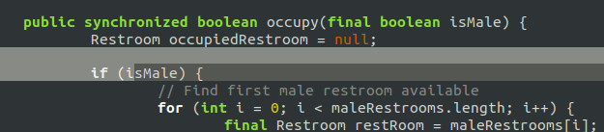
Solution:

